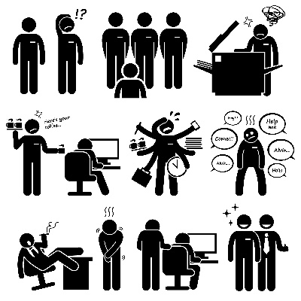

Will a robot take over your job?
…..and if it does, will it really matter?

_________________________________________________________________

This is my latest post - hopefully contributing to your own career planning.

See more suggestions at For Anyone - Coaching (marketingprofessionalsaustralia.com.au)
_________________________________________________________________

ChatGPT

Last week’s email looked at the changing nature of work and the impact of AI on your careers.
Since then, I've looked at ChatGPT to see for myself what it’s capable of. And I asked it for its opinion on the subject......
Q (me). How will AI affect my career?

A (Chatterbox ). The impact of AI on your career will depend on the type of work you do and the specific skills and knowledge you have. In general, AI has the potential to automate some tasks and create new job opportunities in areas such as AI development, data science, and cybersecurity.

If you work in a field that is vulnerable to automation, it may be necessary for you to adapt your skills and knowledge to stay competitive in the job market. For example, if you work in data entry or a similar role, it's likely that AI will increasingly be used to automate these tasks. In this case, it may be helpful to gain experience in areas such as data analysis or AI development to stay relevant and competitive in the job market.

On the other hand, if you work in a field that requires human skills such as creativity, empathy, and critical thinking, it's less likely that AI will replace your job. In these roles, AI may still have an impact, but it's more likely to augment your work and make it more efficient, rather than replace it entirely.
__________________________________________
ChatGPT is a very techie sort of name – needs to be smartened up for general use, in my opinion. I propose ‘Chatterbox’ and will use that from now on in my writings. But I emphasise that it’s only MY name for it.
Also I am assuming it’s gender neutral so will use ‘it’ and ‘its’ rather than s/he or hers/his.

Very interesting, but it’s early days yet with much more development and capability to come .
So let’s look at some scenarios which are ‘vulnerable to automation’:
- Supermarket check-out – currently a very inefficient process and often frustrating for the customer – hence the popularity of self check-out.
However, what’s better still is zero check-out or ‘Just Walkout’!! Popularised by Amazon (Just Walk Out) for use by any retailer and www.amazon.com/dashcart for its own fresh food stores. This now available at Woolworths as ‘scan and go’ Scan&Go at Woolworths | The faster way to shop in store.

This not only eliminates or heavily reduces the need for actual check-out staff but also significantly reduces theft through shop-lifting.

Next on the list might be shelf stacking – currently working or under trial in Japan, Us and UK. In the UK, "TESCO has announced more job cuts, putting 1,400 shelf stacker roles at risk." Tesco is also converting petrol stations at 36 stores to be pay-at-pump only overnight.

- Customer service through enquiries. Probably everyone is used to seeing ‘Chatbots’ pop up on many sites either in response to a query or in any case to help guide web site visitors to where they need to go (or where the site owner wishes them to go!). These are aimed at eliminating or heavily reducing phone/email/text queries, thus eliminating many customer service jobs. Improved versions of Chatterbox will almost certainly be employed here.
- Hospitality venues of all sorts are heavily dependent on people to execute all the necessary tasks - this is both expensive and, in many cases, hard to recruit for.
"Robotic Restaurants Are The Future" according to Forbes magazine. Bon Appétit! Robotic Restaurants Are The Future (forbes.com)

Robot servers: to deliver food to customers
Robot waiters: to order and take away food for customers
Robot cleaners: to clean plates, tables and food for customers
Robot chefs: to cook food for customers
Robot baristas: to make coffee - faster, more consistently

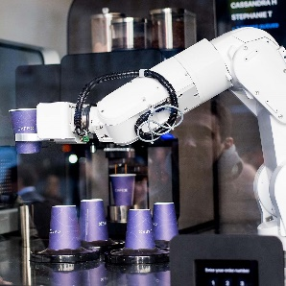 | 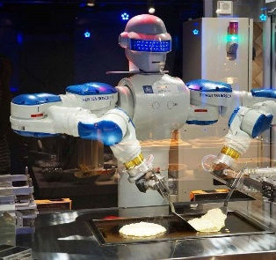

- Tourism, potentially affected by increasing range and complexity of 'immersive experiences' leisure (e.g. THE LUME Melbourne – An Epic Adventure into Art) as well as personal Virtual Reality (VR) facilities

- Most complex factories and warehouses are already fully robotic

I could go on but, after all, this is ONLY AI!! There's a great deal more happening which I will discuss in future emails. But I’d prefer to return to my original theme that it's never too early to be considering your career path. The world is changing perhaps faster than it ever has, due to the increasing range and complexity of digital transformations in our lives.
But if you think back to where you were 5 years ago – before we’d heard of Covid, Tik Tok, electric cars, rise and fall of Donald Trump, war in Europe, earthquakes in middle east – and see how the global economy has changed. Then project forwards 5 years and imagine how YOU might change.
Of course you can’t control EVERYTHING that happens to you and your life, but maybe now is a really good time to be thinking through your career and life options so that you have some degree of control rather than ‘waiting for something to happen’ - que sera, sera, perhaps?
Feel free to call me and arrange a chat over coffee if you like

